The Open Video Digital Library Project has been decommissioned effective July 2025. The project served research and education communities for 25 years (2000-2025). The open access/open source video repository was one of the early video digital libraries on the Internet and served as a research platform for video retrieval and digital library user interface research and became a valued source for curated, freely accessible videos for the K-16 education around the world. 3931 Full-length videos were collected from sources as varied as NASA, the Library of Congress, the Prelinger Archive, and the Association for Computing Machinery (ACM) conferences. Funded primarily by grants from the National Science Foundation (NSF) and the Library of Congress, the project led to research innovations on video data management, faceted search services, and user interface features such as keyframe slide summaries and fast forwards. More than two dozen papers by faculty, students, and post-doctoral fellows at UNC-Chapel Hill and other universities were published in information and computer science journals and conferences (a list appears below).

Screen Shot of Home Page June 2025
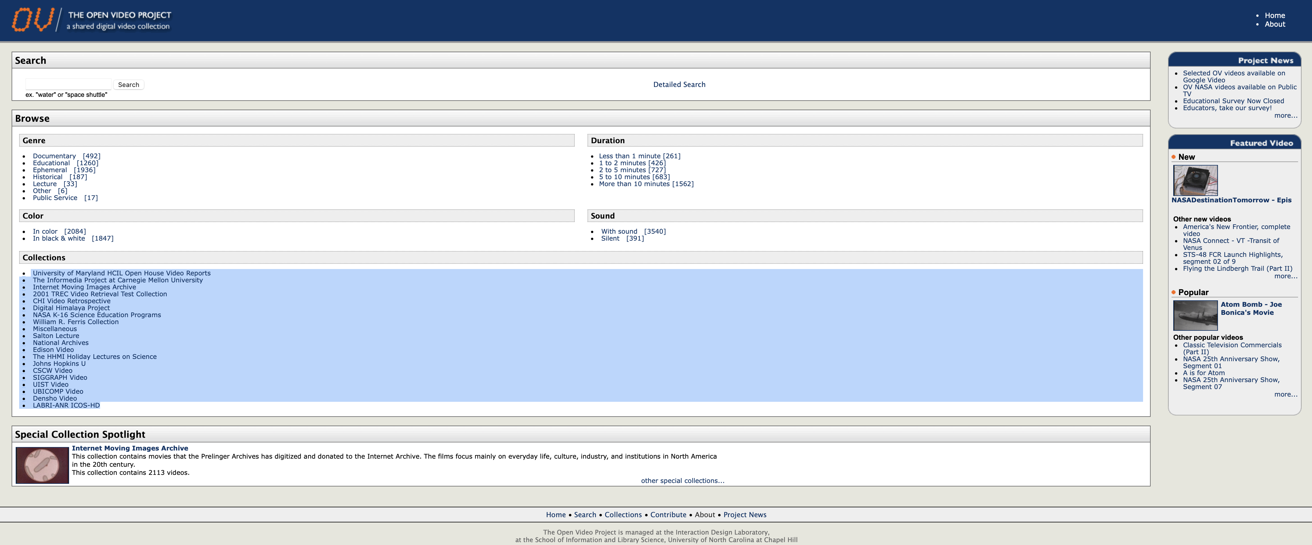

Open Video Digital Library Project Papers 2000-2025

Journal articles
Wildemuth, B., Marchionini, G., Fu, G., Oh, J.S., & Yang, M. (2018). The usefulness of multimedia surrogates for making relevance judgments about digital video objects. Information Processing & Management, 56(6). https://doi.org/10.1016/j.ipm.2019.10209.

Marchionini, G., Song, Y., & Farrell, R. (2009). Multimedia surrogates for video gisting: Toward combining spoken words and imagery. Information Processing & Management. 45(6), p. 615-630.

Marchionini, G. (2008). Digital video policy and practice in higher education: From gatekeeping to viral lectures.
Educational Technology, 48(5), 39-41.

Marchionini, G., Wildemuth, B., & Geisler, G. (2006). The Open Video Digital Library: A Mobius strip of theory and practice. Journal of the American Society for Information Science and Technology. 57(2), 1629-43.

Marchionini, G. (2004). A briefing on the evolution and status of the open video digital library. International
Journal on Digital Libraries, 4(1), 36-38.

Marchionini, G. & Geisler, G. (2002). The Open Video Digital Library. dLib Magazine, 8(12). http://www.dlib.org/dlib/december02/marchionini/12marchionini.html

Marchionini, G. (2003). Video and Learning Redux: New Capabilities for Practical Use. Educational Technology.
43(2), 36-41.

Slaughter, L., Marchionini, G. & Geisler, G. (2000). Open Video: A Framework for a Test Collection. Journal of
Network and Computer Applications, 23(3), 219-245.

Research Conferences
Song, Y., Marchionini, G., & Oh, C. (2010). What are the most eye-catching and ear-catching features in the video? Implications for video summarization. Proceedings of the 2010 WWW Conference. Raleigh, NC, April 26-30,
2010.

Marcos, M. C., Marchionini, G., & Russell, T. (2008). “Personas” y escenarios en el rediseño de la mediateca Open Video Digital. In Proc. IX Congreso Internacional Interacción Persona-Ordenador 2008. Presented at the IX Congreso Internacional Interacción Persona-Ordenador (pp. 127-130).
Song, Y. & Marchionini, G. (2007). Effects of Audio and Visual Surrogates for Making Sense of Digital Video. Proceedings of ACM Conference on Human-Computer Interaction..CHI 2007. (April 28-May 3, 2007 • San Jose, CA), NY: ACM Press. 867-876.

Marchionini, G. (2006). Human Performance Measures for Video Retrieval. Proceedings of the Multimedia Information Retrieval Workshop (ACM Multimedia 2006). (October 23-27, 2006; Santa Barbara, CA), NY:ACM Press. 307-311.

Tibbo, H. R., Lee, C. A., Marchionini, G., & Howard, D. (2006). VidArch: preserving meaning of digital video over time through creating and capture of contextual documentation. In Archiving 2006. Final Program and Proceedings (May 23-26, 2006, Ottawa, Ont., Canada) (pp. 210-215): Society for Imaging Science and Technology.

Yang, M. & Marchionini, G. (2005). Deciphering visual gist and its implications for video retrieval and interface design. Proceedings of the Conferences on Human Factors in Computing Systems (CHI). pp. 1877-1880. Portland, OR. Apr. 2-7, 2005

Yang, M., Wildemuth, B., & Marchionini, G. (2004). The relative effectiveness of concept-based versus content- based video retrieval. Proceedings of the 12th annual ACM international conference on Multimedia, pp. 368 - 371.

Yang, M. & Marchionini, G. (2005). Exploring users’ video relevance criteria: A pilot study. Annual Meeting of the Society for Information Science and Technology (Providence, RI, Nov 12-17). pp. 229-238.

Yang, M., Wildemuth, B. & Marchionini, G. (2004). The relative effectiveness of concept-based versus content- based video retrieval. ACM Multimedia conference (New York, Oct 10-16).

Yang, M., Wildemuth, B., Marchionini, G., Wilkens, T., Geisler, G., Hughes, A., & Gruss, R. (2003). Measuring user performance during interactions with digital video collections. Proceedings of the American Society for Information Science and Technology Annual Conference (Long Beach, CA, Oct. 19-22, 2003), p. 3-11.

Mu, X. & Marchionini, G. (2003). Enriched video semantic metadata: Authorization, integration, and presentation. Proceedings of the American Socierty for Information Science and Technology Annual Conference (Long Beach, CA, Oct. 19-22, 2003), p. 316-322.

Hughes, A., Wilkens, T., Wildemuth, B., Marchionini, G. (2003). Text or Pictures? An Eyetracking Study of How People View Digital Video Surrogates. Proceedings of CIVR 2003, Urbana-Champaign, IL: July 24-24, 2003. Lecture Notes in Computer Science #2728. pp. 271-280.

Wilkens, T., Hughes, A., Wildemuth, B. & Marchionini. G. (2003). The role of narrative in understanding digital video: An exploratory analysis. Proceedings of the American Socierty for Information Science and Technology Annual Conference (Long Beach, CA, Oct. 19-22, 2003), p. 323-329.

Wildemuth, B., Marchionini, G., Yang. M., Geisler, G., Wilkens, T., Hughes, A., & Gruss, R. (2003). How fast is too fast? Evaluating fast forward surrogates for digital video. Proceedings of the ACM/IEEE Joint Conference on Research on Digital Libraries (Houston, TX: May 27-31, 2003)., Los Alamitos, CA: IEEE. pp. 221-230. Received Vannevar Bush Best Paper Award

Meng, Y., Mu., X., & Marchionini, G. (2003). VIVO: A video indexing and visualization organizer (Poster).
Proceedings of the ACM/IEEE Joint Conference on Research on Digital Libraries (Houston, TX: May 27-31,
2003)., Los Alamitos, CA: IEEE. P. 403.

Hughes, A., Wilkens, T., Wildemuth, B., & Marchionini, G. (2003). Text or Pictures? An Eyetracking Study of How People View Digital Video Surrogates. Second International Conference on Video Retrieval (CIVR 2003). University of Illinois, July 24-25, 2003). Lecture Notes in Computer Science 2728. Berlin, Springer. 271-280.

Wildemuth, B. Marchionini, G., Wilkens, T., Yang, M., Geisler, G., Fowler, B., Hughes, A., & Mu, X. (2002) Alternative Surrogates for Video Objects in a Digital Library: Users’ Perspectives on Their Relative Usability. Proceedings of the 6th European Conference ECDL 2002 on Research and Advanced Technology for Digital Libraries, Berlin: Springer. (Rome, September 16-18, 2002) 493-507.

Geisler, G., Marchionini, G.,Wildemuth, B., Hughes, A., Yang, M., Wilkens, T., & Spinks, R. (2002). Video browsing interfaces for the Open Video Project. Proceedings of CHI 02, Extended Abstracts (Minneapolis, MN, April 20-25, 2002). NY: ACM Press. 514-15.

Karthikeyan, M., Uzagare, S., Krishnan, S., Meng, Y., & Marchionini, G. (2002). Searching video segments through transcript, metadata, and SVG objects. In E. P. Lim, S. Foo, C. Khoo, H. Chen, E. Fox, S. Urs & T. Costantino (Eds.), Digital Libraries: People Knowledge and Technology. 5th International Conference on Asian Digital Libraries, ICADL 2002. Proceedings (Dec 11-14, 2002, Singapore) (pp. 528-528): Springer-Verlag.

Geisler, G., Marchionini, G., Nelson, M., Spinks, R., & Yang, M. (2001). Interface concepts for the Open Video Project. Proceedings of the Annual Meeting of the American Society for Information Science (Washington, DC, Nov. 5-8, 2001). 58-75.

Nelson, M., Marchionini, G., Geisler, G., & Yang, M. (2001). A Bucket Architecture for the Open Video Project.
Proceedings of JCDL 2001: Joint Conference on Digital Libraries (Roanoke, VA, June 24-28, 2001), 310-11

Geisler, G. & Marchionini, G. (2000) The Open Video Project: a research-oriented digital video repository
ACM Digital Library Conference. (San Antonio, June 4-6, 2000), 258-259.

GitHub tool kit by Gary Geisler
https://github.com/ovdlt/open-video-digital-library-toolkit

